**Experiment No :** 03

**Experiment name :** Write a program that will count the number of occurrences of specified character in a given line of test .

**Methodology :**

This program allows the user to enter a string (or character array), and a character value.

Next, the C program will search and count the total number of times this character has occurred

inside a string.

**Flow-Chart :**

for(i =0 ; i<strlen(word) ; i++

Declear ->char[100] , ch ;

Int i , count = 0 ;

**Code :**

if(word[i] == chr){

count++;

}

Output : printf(chr , count)

Input a sentense

Gets(word) ;

Enter elements of first matix :

Input a word

Scanf(“%c”,&ch) ;

#include<stdio.h>

#include<string.h>

int main(){

char word[100] , chr ;

int i , count = 0;

printf("Enter any word : ");

gets(word);

printf("Enter the chracter that you want to search for : ");

scanf("%c",&chr);

for(i =0 ; i<strlen(word) ; i++){

if(word[i] == chr){

count++;

}

}

printf("\n The total number of time '%c' has occured = %d ",chr , count);

return 0;

}

**Output:**

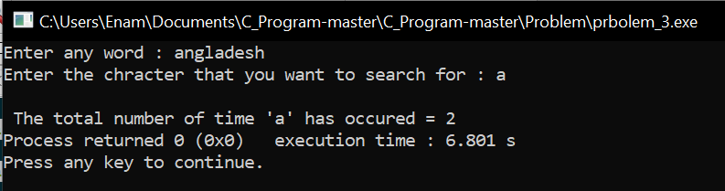

**Result discussion :**

We will use this program for that task. That is, to find out how many words of the same type are there in a sentence, suppose I said Bangladesh, how many A or B are there or, what is the number of any other words? We wrote this program to find out